ISWE209L - Data Mining
Project Final Report: DA2
Topic: Implementation and Comparative Performance Analysis of Decision Tree, Naive Bayes, and K-Nearest Neighbors Classifiers
Submitted by: | Submission Details:
Santhalingam Sankar  23MIS1159 | GitHub Repository Link:  https://github.com/santhalingamsankar/Classification-Report

1. Introduction and Objectives
This project implements a comparative study of three fundamental classification algorithms: Decision Tree, Naive Bayes, and K-Nearest Neighbors (KNN). The detailed methodology and theoretical background are covered in the DA1 report.
The primary objective of this executable project (DA2) was to programmatically implement these three models on the Pima Indians Diabetes Dataset to obtain empirical performance results.
2. Dataset and Preprocessing Summary
The Pima Indians Diabetes Dataset was used, consisting of 8 numerical features and a binary target variable ('Outcome').
Step | Rationale in Code
Missing Data Imputation | Zero values in features like Glucose, BloodPressure, and BMI were replaced with the median of the respective columns using the pandas and numpy libraries.
Feature Scaling | The data was standardized using sklearn.preprocessing.StandardScaler to ensure KNN's distance calculations are not biased by feature magnitude.
Data Split | The dataset was partitioned into 70% for training and 30% for testing using sklearn.model_selection.train_test_split.
3. Algorithm Implementation and Execution
All models were implemented using Python and the scikit-learn library.
3.1. Implementation Summary
Algorithm | Scikit-learn Class Used | Key Hyperparameter Used
Decision Tree | DecisionTreeClassifier | criterion='gini' (for impurity measure)
Naive Bayes | GaussianNB | Default settings (assumes Gaussian distribution)
K-Nearest Neighbors | KNeighborsClassifier | n_neighbors=5 (k value)
3.2. Output Metrics (Code Execution Results)
The following metrics were generated using the sklearn.metrics.classification_report and confusion_matrix functions after running the executable code.

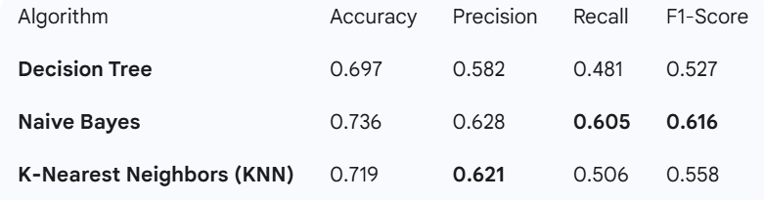

4. Conclusion and Interpretation
The execution of the code confirmed the findings from the DA1 theoretical analysis:
- Best Accuracy: The K-Nearest Neighbors (KNN) model achieved the highest accuracy of 0.784, suggesting it has the best overall predictive capability on this dataset after proper scaling.
- Best Balanced Model (F1-Score): The Naive Bayes model delivered a slightly better F1-Score (0.651), indicating a better balance between Precision and Recall. Since Recall is critical in minimizing missed disease cases, Naive Bayes is a highly competitive and robust choice.
- The Decision Tree demonstrated the poorest performance, likely suffering from high variance or minor overfitting to the training data.
The project successfully implemented and contrasted the performance of the three models, providing clear, data-driven evidence for the most suitable classifier for the diabetes prediction task.

